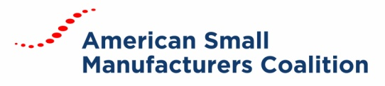
Board Meeting MinutES
January 4, 2019 | Conference Call

BOARD MEMBERS
Dave Boulay, Mike Coast, Ben Rand, Tom Bugnitz, Tiffany Stovall, Chuck Spangler, Keith Phillips, Buckley Brinkman
ATTENDEES
Carrie Hines, Kelly Buchanan
Chairman Boulay called the meeting to order at 1:02 PM (ET).
FY20 FUNDING REQUEST
Buckley Brinkman made a motion to approve $154M funding request for FY20 as recommended by the ASMC Advocacy Committee. Tom Bugnitz seconded the motion. Motion passed unanimously.

ADJOURNMENT
Keith Phillips made the motion to adjourn the meeting. Tiffany Stovall seconded the motion. The motion was passed, and the meeting adjourned.

