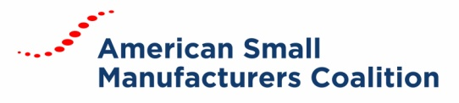

Board Meeting MinutES
February 19, 2019 | Conference Call

BOARD MEMBERS
Keith Phillips, Tom Bugnitz, Buckley Brinkman, Chuck Spangler, Dave Boulay, Karen Fite, Mike Coast, Tiffany Stovall, Ben Rand
ATTENDEES
Carrie Hines, Kelly Buchanan
Chairman Boulay called the meeting to order at 1:00 PM (ET).
APPROVAL OF MEETING MINUTES
Following a small edit in the advocacy section, Karen Fite made a motion to approve the January 2019 minutes. Tiffany Stovall seconded the motion. The motion was approved.

REVIEW OF FY19 FINANCIALS
Hines presented the current FY19 financials and updated the board on the year end projections. An update on Centers’ membership standings was also presented to the board.

ADVOCACY AND HILL DAY UPDATE
The FY19 budget has now been approved. We will now focus all advocacy efforts on our FY20 Ask.

The attendance for the upcoming Hill Day has decreased from the prior year. We learned there is a conflicting meeting, which may have been the cause for Centers lack of participation.

Senator Coons and Senator Peters have confirmed their attendance at the Opening Reception and will both address attendees.

REVIEW OF POLITICAL ACTION COMMITTEE
The PAC will be sponsoring a breakfast for Senator Coons on Thurs., Feb. 28. Hine’s attendance was requested and she will be attending following the Hill Day breakfast.

ADJOURNMENT
Ben Rand made the motion to adjourn the meeting. Chuck Spangler seconded the motion. The motion was passed, and the meeting adjourned.

