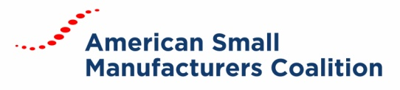

Board Meeting MinutES
January 15, 2019 | Conference Call

BOARD MEMBERS
Dave Boulay, Eric Esoda, Karen Fite, Ben Rand, Buckley Brinkman, Chuck Spangler, Mike Coast, Tiffany Stovall, Tom Bugnitz
ATTENDEES
Carrie Hines, Kelly Buchanan
Chairman Boulay called the meeting to order at 1:00 PM (ET).
APPROVAL OF MEETING MINUTES
The minutes of the August 21, 2018 and January 4, 2019 were reviewed. Buckley Brinkman made a motion to approve both sets of minutes. The motion was seconded by Chuck Spangler. Motion passed unanimously.

REVIEW OF FY19 FINANCIALS
Hines reviewed the new formatting of the FY19 financial documents and updated the board on current standings.

ADVOCACY AND HILL DAY UPDATE
The government remains to be shutdown. Possible scenarios for re-opening were discussed. Negotiations are ongoing, but things currently remain at an impasse.

An update regarding the registration, hotel room block and agenda was provided to the board. Information regarding the upcoming webinars was also provided. Drafts of Hill Day materials has been provided for feedback before posting to the web for attendee access.

REVIEW OF POLITICAL ACTION COMMITTEE
An update on the PAC was provided. There has been a slowdown of donations and concern about its relevancy. It will be up to the PAC Board to determine its future.

ADJOURNMENT
Mike Coast made the motion to adjourn the meeting. Chuck Spangler seconded the motion. The motion was passed, and the meeting adjourned.

